|  |
| --- |
| **EX NO:5 ONLINE COURSE RESERVATION SYSYEM** |

SEQUENCE DIAGRAM:

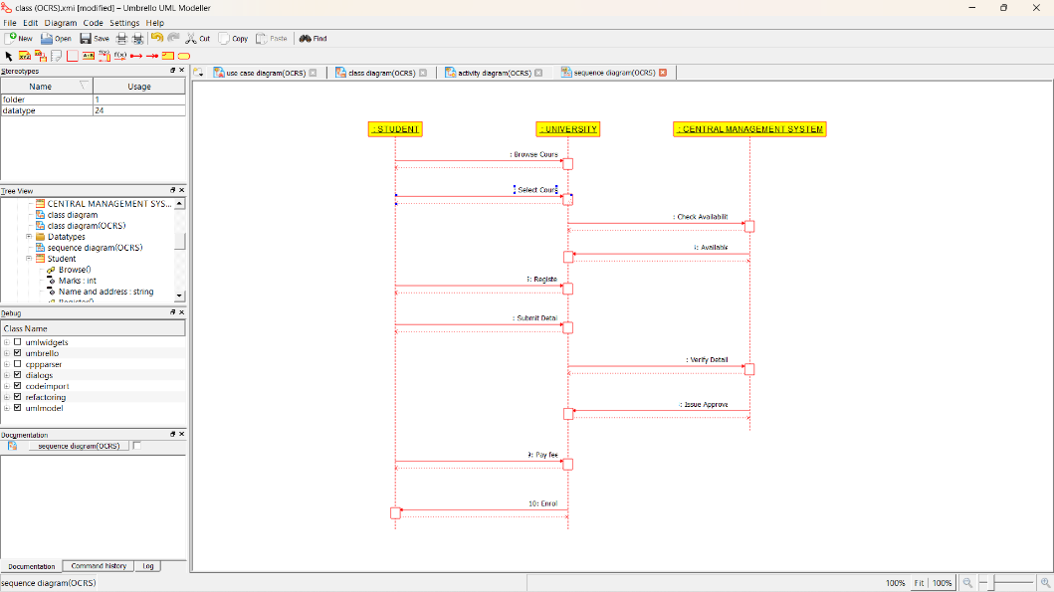

COLLABORATION DIAGRAM:

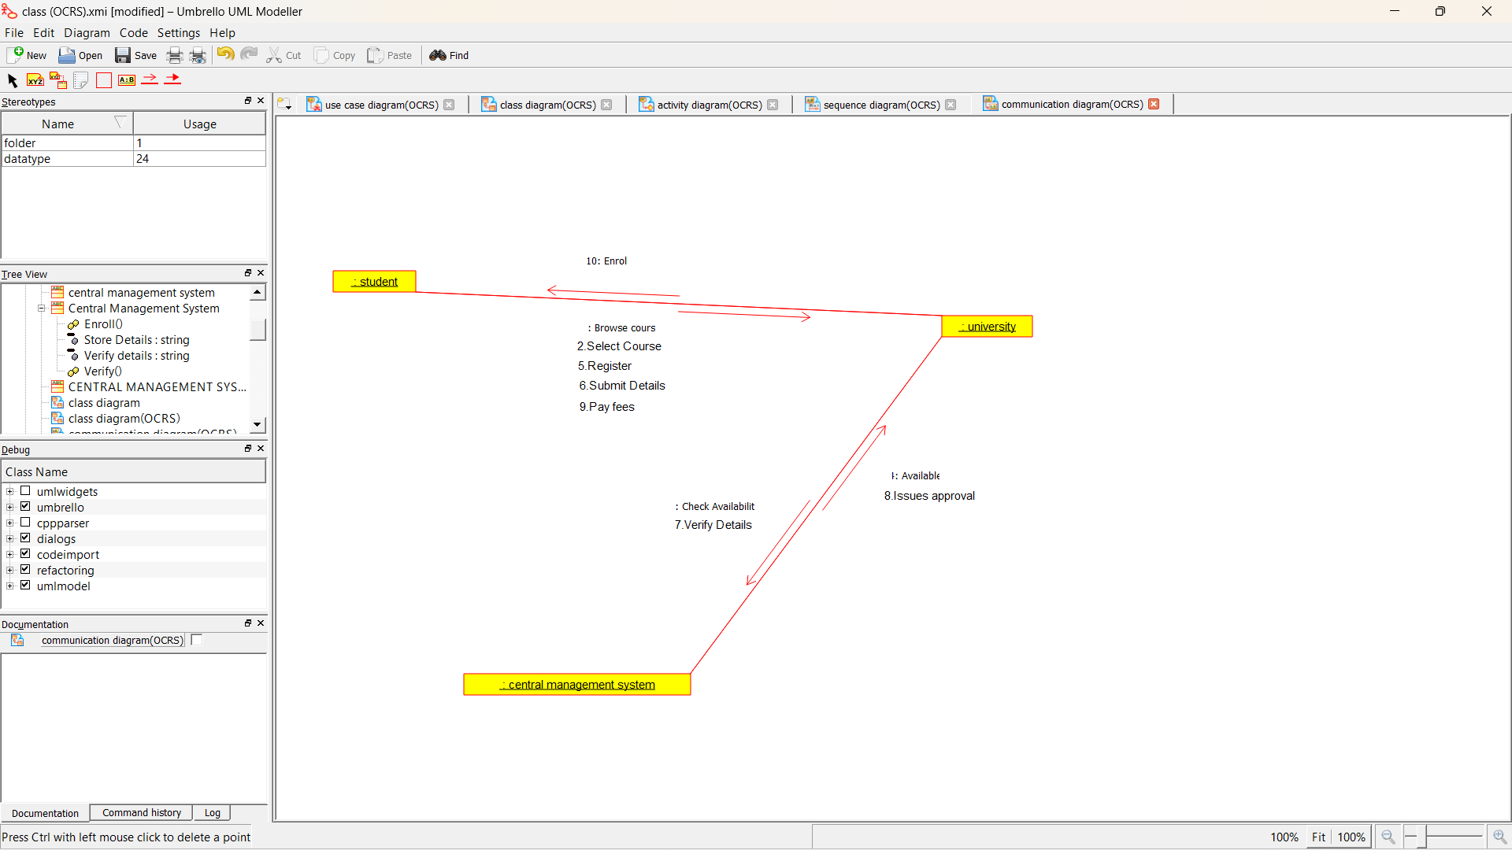

COMPONENT DIAGRAM:

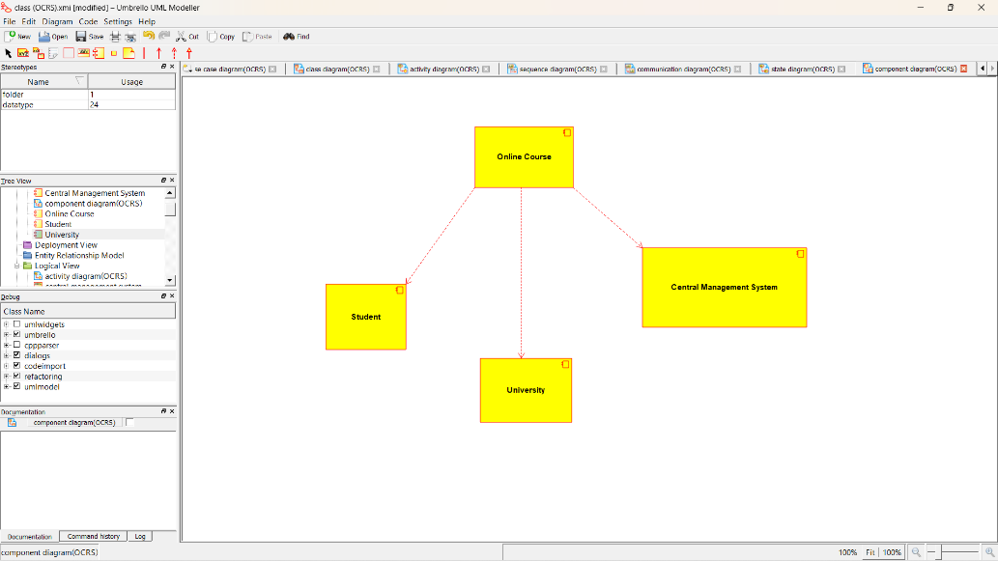

DEPLOYMENT DIAGRAM:

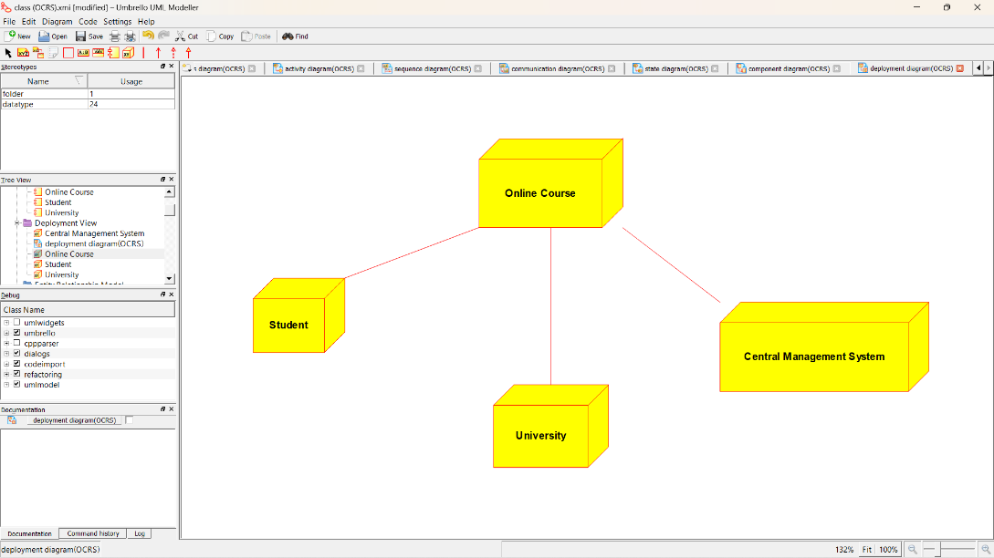

USE CASE DIAGARAM

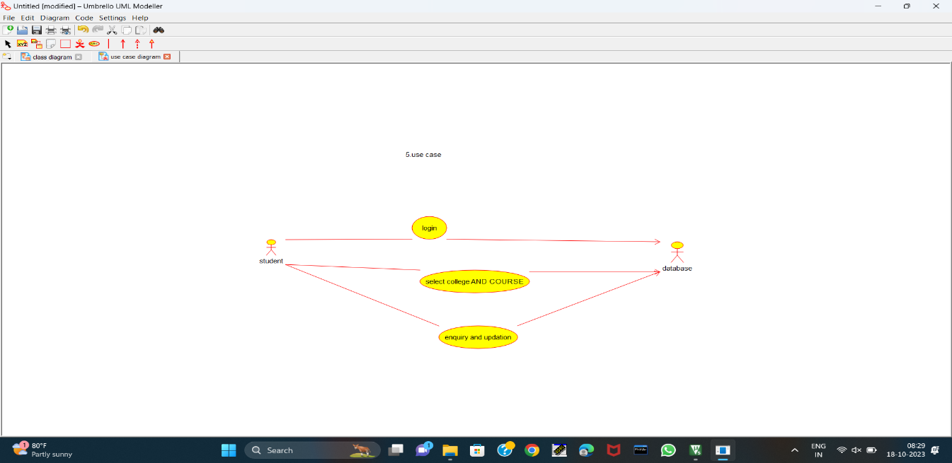

CLASS DIAGARAM

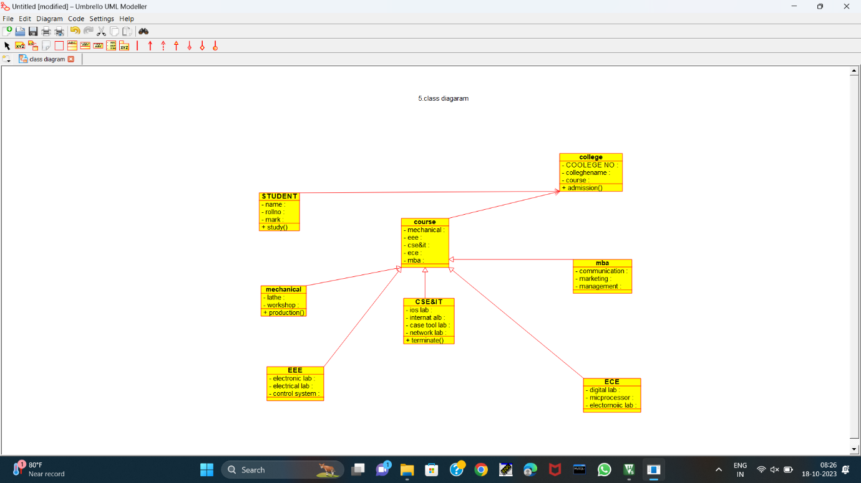

ACTIVITY DIAGARAM

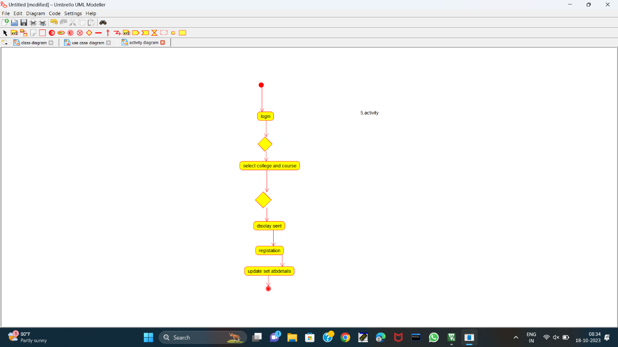

STATE CHART DIAGARAM

